**Output** or **Print Statement in Java:**

In Java, there are several methods available for printing output to the console, primarily provided by the **System** **class** and its **out** **stream**.

1. **System.out.print():**

This method prints text to the console **without adding a new line** **(\n)** at the end. Subsequent print statements will continue on the same line.

**Example:**

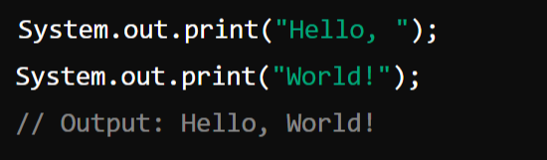

1. **System**.**out**.**println**():

This method prints text to the console and **adds a new line at the end**. Each subsequent print statement will start on a new line.

1. **System.out.printf():**

This method provides formatted output similar to printf() in C. It's useful when you need to format the output in a specific way, such as aligning text or including variables within a string.

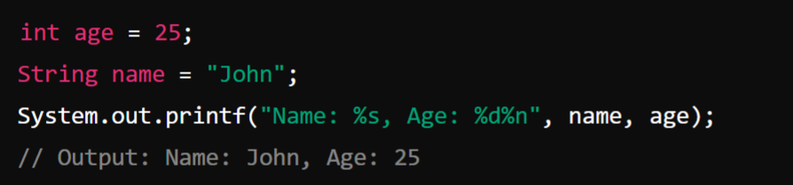

The **%s** is a placeholder for a **string**, and **%d** is a placeholder for an **integer**. The **%n** is a platform-independent **newline** **character**.

1. **System.out.format()**

This method is essentially the same as System.out.printf() and can be used interchangeably.

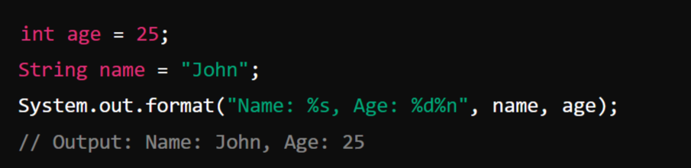

**Input Statement in Java:**

In Java, taking input from the user is commonly done using the **Scanner** class, which is part of the **java.util** package. Other than Scanner we have many other Classes that will discuss in the upcoming classes.

**Example: How to use the Scanner class to read different types of input,**

1. **Importing the Scanner Class:**

1. **Creating a Scanner Object:**

You create a Scanner object to read input from various sources, such as the console, files, or strings. To read input from the console, you typically create a Scanner object using **System.in:**

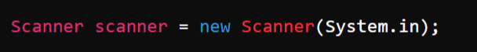

1. **Reading Different Types of Input**

The Scanner class provides methods to read different types of input:

1. **Reading a String:**

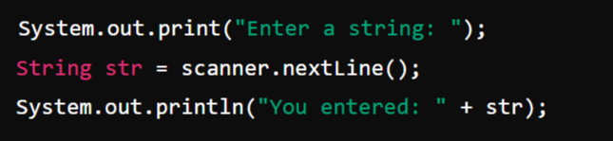

1. **Reading an Integer:**

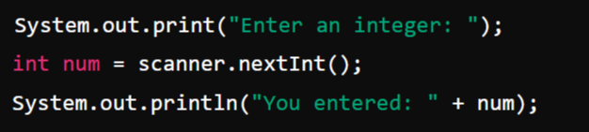

1. **Reading an Float:**

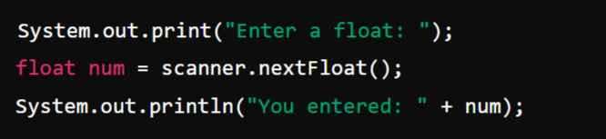

1. **Reading an Double:**

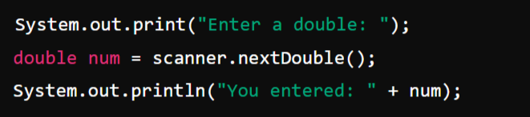

1. **Reading an Boolean:**

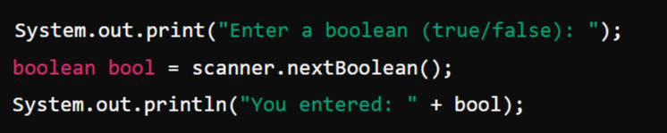

1. **Reading an Character:**

